Experiment 6: NoSQL Database using MongoDB

1. Start mongod service and type mongo to enter into mongo terminal.

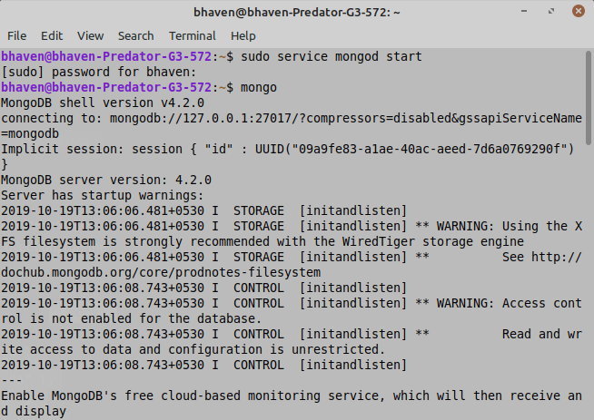

**Create Statements:**

1. Step 1: Create database with **use** command

use mongodemo

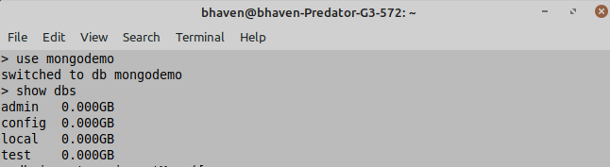

1. Insert some data into the table for the database to be created and the data is inserted into Collections or alternatively you can use db.createCollection(name, options).

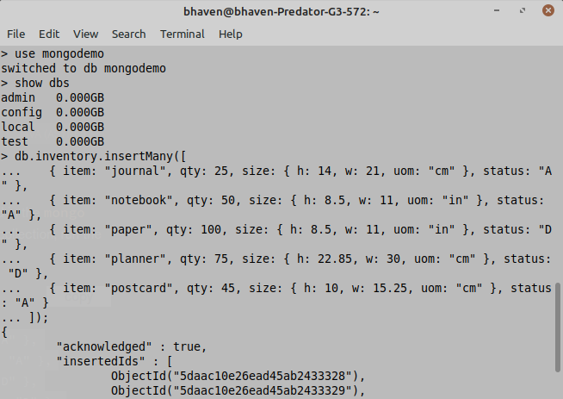

**Read Statements:**

1. To view data stored in the Collection:

db.inventory.find( {} ) (Similar as select statement in SQL)

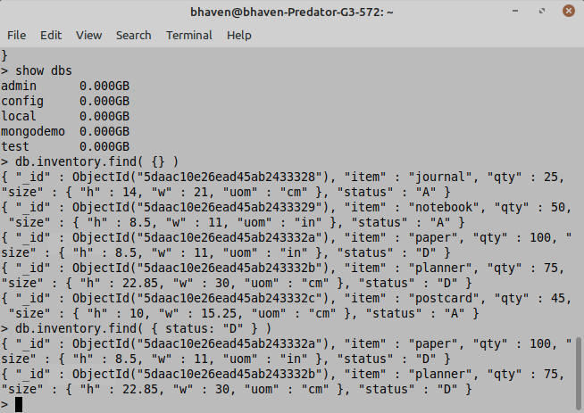

Specify Equality Condition:

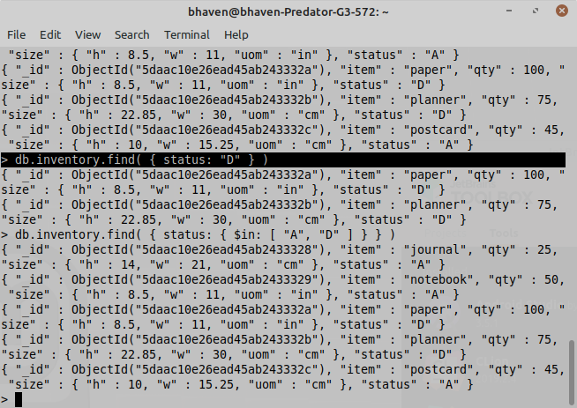

Specify Conditions Using Query Operators:

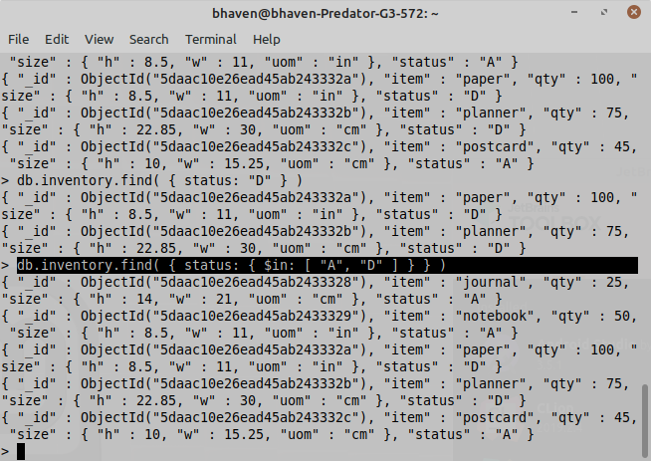

Specify AND as well as OR Conditions:

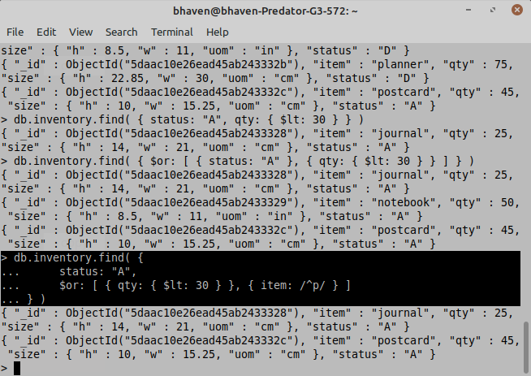

Specify AND Conditions:

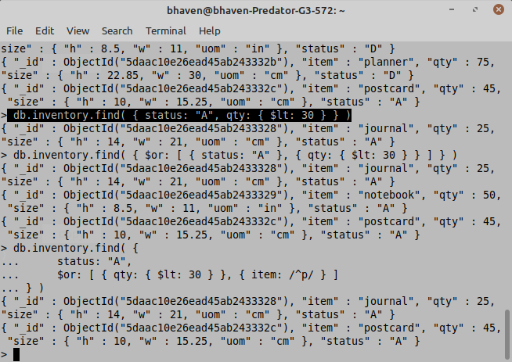

Specify OR Conditions:

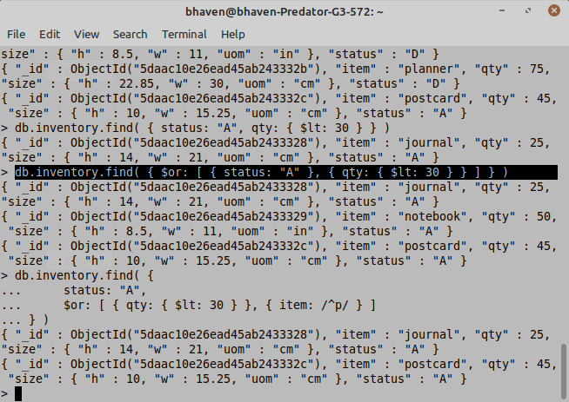

**Update Statements:**

1. To update a record in the Collection:

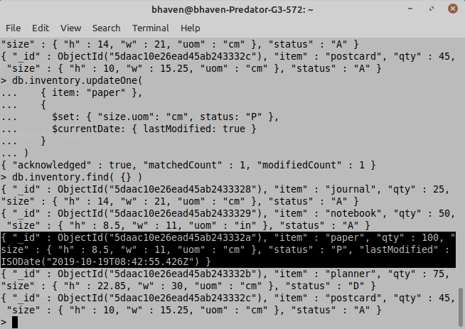

**Delete Statements:**

1. To delete a record from the Collection:

